**Intro to Exponentials and Logarithms**

When working with exponents, we need to keep in mind that we are simply applying an operation (or definition).

For example, $2^{5}$ means to multiply 2 by itself 5 times. So $2^{5}=2\left(2\right)\left(2\right)\left(2\right)\left(2\right)=32$

When working with logarithms, we need to force ourselves into the same mindset, namely, that we are simply applying an operation.

For example, $\log_{3}{(27)}$ means to apply the logarithm operation in base 3 to the value 27.

Although we may not be comfortable with exponentials and logarithms, mainly because we don’t use these operations as often as we do addition, subtraction, multiplication, division, we need to constantly remind ourselves that they really are just operations.

Over the next few weeks we will be focusing solely on these two operations (exponentials and logarithms), which also happen to be opposites or inverses of each other.

Using exponents, since $3^{3}=27$ we can now determine that $\log_{3}{(27)}=3$

**Logarithms on a Calculator**

Most scientific calculators have two options for working with logarithms. It is important to note the following:

When the base of a logarithmic function is the irrational number $e≈2.718$, we use the natural log notation:

$$\log_{e}\left(x\right)=\ln\left(x\right)$$

In words, “log base $e$ of $x$” is the same as “natural log of $x$”.

When no base is visible, it is assumed that the base is 10.

$$\log\left(x\right)=\log_{10}{(x)}$$

In words, “log of $x$” is the same as “log base 10 of $x$”.

Verify the following using a calculator:

$\log\left(118\right)≈2.07$ $\ln\left(118\right)≈4.77$ $\log\left(1000\right)=3$ $\ln\left(e^{2}\right)=2$

This should demonstrate to you that logarithms simply take input and perform some operation to obtain the resulting output. We will now take a more in-depth look at these types of functions.

**Exponential Functions**

An exponential function has the general form

$$f\left(x\right)=a{∙b}^{x}$$

where $a$ (the initial value) is any nonzero number and $b$ (the base) is any positive number not equal to 1.

* If $b>1,$ then the exponential function grows at a rate proportional to its size
* If $0<b<1,$ then the exponential function decays at a rate proportional to its size
* The domain is $\left(-∞,∞\right)$
* The range is $\left(0,∞\right)$ for $a>0$ and is $(∞, 0)$ for $a<0$
* The horizontal asymptote is $y=0$ and the $y$–intercept is $(0,a)$

Example 1: Determine which of the following functions are exponential.

$f\left(x\right)=2∙{\left(-3\right)}^{x}$ $g\left(x\right)=-{\left(\frac{1}{5}\right)}^{x}$ $h\left(x\right)={4x}^{3}$ $j\left(x\right)=\frac{7}{{10}^{x}}$

**Graphs of Exponential Functions**

Let’s look at a partial input/output table and the corresponding graph of $f\left(x\right)=2^{x}$

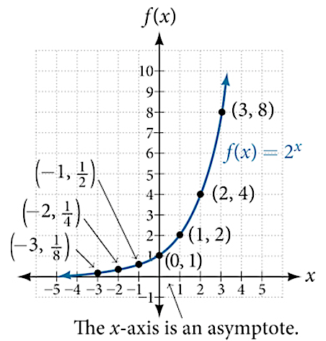

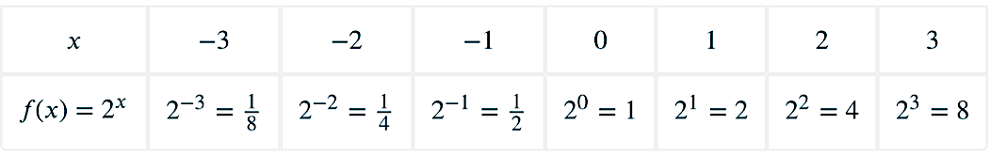

Notice that no input value results in a negative (or zero) output value.

Thus, as $x→-∞, f(x)→0^{+}$ and as $x→∞, f(x)→∞$.

For any exponential of the form $f\left(x\right)=b^{x}$, three key points will be

$$\left(-1,\frac{1}{b}\right), \left(0,1\right), \text{and} (1, b)$$

**Transformations**

For an exponential function, $f\left(x\right)=ab^{x}$, the initial value $a$ is similar to the vertical stretch/compression factor when we first visited transformations, and thus if $a<0,$ there is a vertical ($x$–axis) reflection. If we introduce a multiplicative factor in the exponent, such as $g\left(x\right)=ab^{cx}$, we would have a horizontal stretch/compression with a possible horizontal ($y$–axis) reflection depending on the value of $c$.

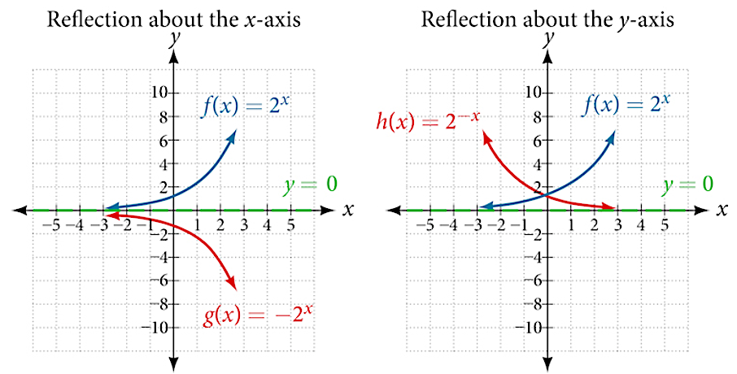

Shifts are still attributed to addition/subtraction of a value either in the exponent, $t\left(x\right)=ab^{x-h}$ (horizontal shift) or after the exponential, $u\left(x\right)=ab^{x}+k$ (veritical shift)

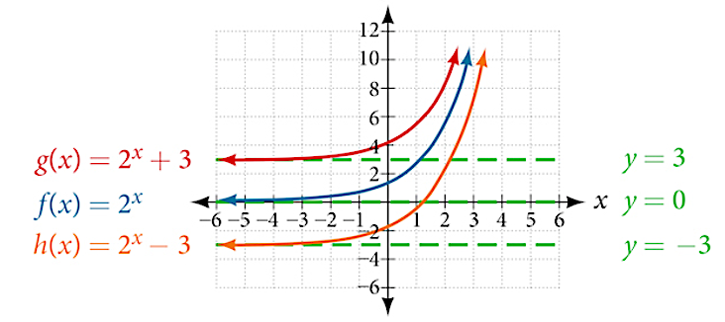

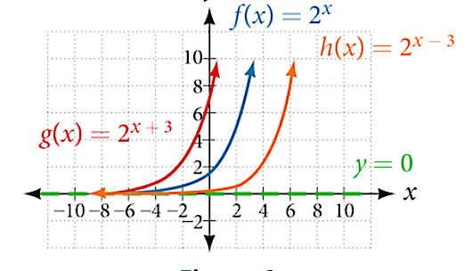

We will not specifically work with the graphs of exponential functions including transformations without technology. However, you are responsible for understanding the connections to the concepts of transformations outlined above and below.

|  |  |
| --- | --- |
| Transformation of the parent function $f\left(x\right)=b^{x}$ | |
| $$f\left(x\right)=b^{x-h}$$ | Horizontal Shift $h$ units |
| $$f\left(x\right)=b^{x}+k$$ | Vertical Shift $k$ units |
| $$f\left(x\right)=ab^{x}$$ | Vertical Stretch/Compression and Vertical ($x$–axis) Reflection if $a<0$ |
| $$f\left(x\right)=b^{cx}$$ | Horizontal Stretch/Compression and Horizontal ($y$–axis) Reflection if $c<0$ |

**Modeling with Exponentials**

When using exponential functions to describe growth or decay, there is usually a notation change, although the meaning is the same.

$A\left(t\right)=A_{o}b^{t}$ $N\left(t\right)=N_{0}b^{t}$

Here the lead coefficients $A_{0}$ and $N_{0}$ are the initial values, $b$ is the base and determines growth $(b>1)$ or decay $\left(0<b<1\right)$, and $t$ is the input variable which is usually a measure of time. The function names of $A$ and $N$ are typically chosen as the output is either an “amount” or a “number” of something.

Example 2: Below is the growth model for a particular wildlife species that were reintroduced in a protected area.

$$N\left(t\right)=80{\left(1.145\right)}^{t}$$

How many of this particular species were originally reintroduced?

How many of this particular species will be present in 5 years?

Another common application of exponentials is Compound Interest. Here we can model the value of a financial account by

$$A\left(t\right)=P{\left(1+\frac{r}{n}\right)}^{nt}$$

Where $P$ is the original principal, $r$ is the interest rate written as a decimal, $n$ is the number of annual compoundings, and $t$ is time.

Example 3: Suppose you invest $5,000 in an account that pays 5% interest compounded quarterly. How much will the account be worth in 10 years?

**Logarithmic Functions**

A logarithmic function has the general form

$$f\left(x\right)=\log_{b}{(x)}$$

where $b$ (the base) is any positive number not equal to 1.

* + The domain is $\left(0,∞\right)$
  + The range is $\left(-∞,∞\right)$
  + The vertical asymptote is $x=0$ and the $x$–intercept is $(1,0)$

Logarithmic functions are the inverses of exponential functions with the same base value. In other words,

If $f\left(x\right)=b^{x}$ then $f^{-1}\left(x\right)=\log_{b}{(x)}$

This leads us to a way to convert between the worlds of exponential and logarithmic functions.

$$b^{x}=y ⟺ \log_{b}\left(y\right)=x$$

Notice since these are opposite operators, we are essentially switching inputs and outputs.

Example 4: Convert each logarithmic equation to its equivalent exponential equation and solve.

$\log_{2}\left(x\right)=4$ $\log_{3}{(2x+5)}=3$ $\log_{4}{(2x)}=3$

Example 5: Convert each exponential equation to its equivalent logarithmic equation and solve.

${10}^{2x-3}=118$ $e^{3-x}=118$

**Graphs of Logarithmic Functions**

Let’s return to the exponential function, $f\left(x\right)=2^{x}$ which we graphed earlier. Using the properties of inverse functions, let’s add the table and graph ${g\left(x\right)=f}^{-1}\left(x\right)=\log_{2}{(x)}.$

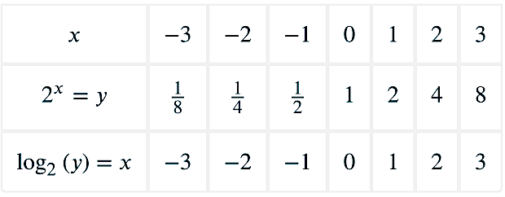 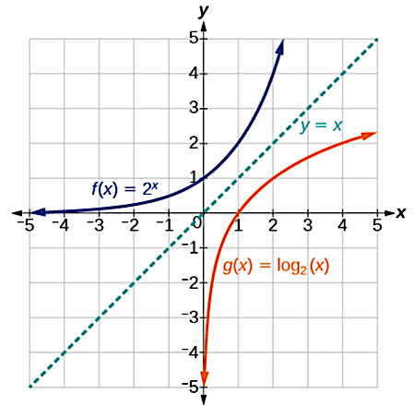

Notice these graphs are symmetric about the identity line, $y=x$.

Example 6: Determine the domain, range, intercepts, and asymptotes of the functions above.

**Transformations**

Similar to the way we worked with exponential functions, we will not specifically work with the graphs of logarithmic functions including transformations without technology. However, you are once again responsible for understanding the connections to the concepts of transformations outlined below.

|  |  |
| --- | --- |
| Transformation of the parent function $f\left(x\right)=\log_{b}{(x)}$ | |
| $$f\left(x\right)=\log_{b}{(x-h)}$$ | Horizontal Shift $h$ units |
| $$f\left(x\right)=\log_{b}{(x)}+k$$ | Vertical Shift $k$ units |
| $$f\left(x\right)=a\log_{b}{(x)}$$ | Vertical Stretch/Compression and Vertical ($x$–axis) Reflection if $a<0$ |
| $$f\left(x\right)=\log_{b}{(cx)}$$ | Horizontal Stretch/Compression and Horizontal ($y$–axis) Reflection if $c<0$ |

**Properties of Exponentials and Logarithms**

$b^{0}=1$ $\log_{b}{(1)}=0$

$b^{x}∙b^{y}=b^{x+y}$ $\log_{b}\left(x∙y\right)=\log_{b}{(x)}+\log_{b}\left(y\right)$

$\frac{b^{x}}{b^{y}}=b^{x-y}$ $\log_{b}\left(\frac{x}{y}\right)=\log_{b}{(x)}-\log_{b}\left(y\right)$

${\left(b^{x}\right)}^{y}=b^{x∙y}$ $\log_{b}{(x^{y})}=y∙\log_{b}{(x)}$

$b^{\log_{b}\left(x\right)}=x$ $\log_{b}{(b^{x})}=x$

$b^{-x}=\frac{1}{b^{x}}$ $\log_{b}\left(\frac{1}{x}\right)=-\log_{b}{(x)}$

Example 7: Use the properties above to write each expression using a single logarithm.

$3\ln{(x)}-2\ln\left(5\right)-\frac{1}{2}\ln\left(e\right)$ $\log_{2}{(4x)}-3\log_{2}{(}3)$

Example 8: Use the properties above to write each expression as the sum/difference of logarithms.

$\log_{3}\left(\frac{27}{\sqrt{x-2}}\right)$ $\ln\left(\frac{16x^{3}}{5e^{2}}\right)$